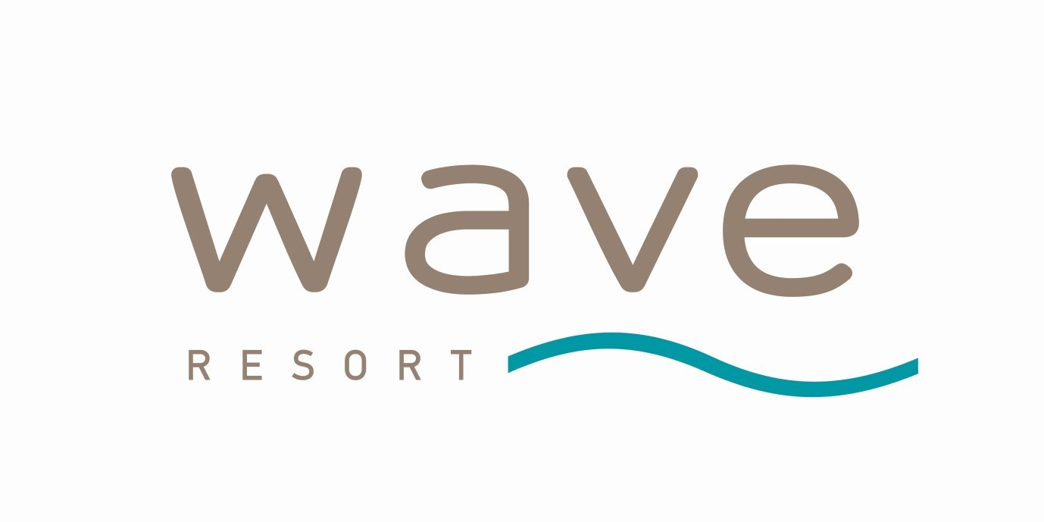

WAVE CLUB

WAVE CLUB programme supplement can be booked for any type of room and includes the following benefits:

- Welcome package (a bottle of Prosecco, candies and nuts);
- Separate check-in;
- Personal Concierge;
- Breakfast and lunch in the a-la-carte restaurants;
- Unlimited access to the a-la-carte restaurants for dinner*;
- Room service from 7:30 to 21:00;
- Pillow menu;
- Wider variety of room amenities;
- Beach bag;
- Good bye gift;
*in April, May, September and October only 2 a-la-carte restaurants might be operating;

